Installation Manual

Model - MG-ANT-28

Product Description
Digital Flat Panel TV Antenna

Technical Specifications
*Frequency range: UHF: 470~862MHz
*Polarization: Horizontal
*Input voltage: AC 120V
*Output voltage: DC6V/100mA
*Impedance: 75 Ω
*Connector: F connector

Installation Steps
1. Connection and usage
(A) Powered by adaptor
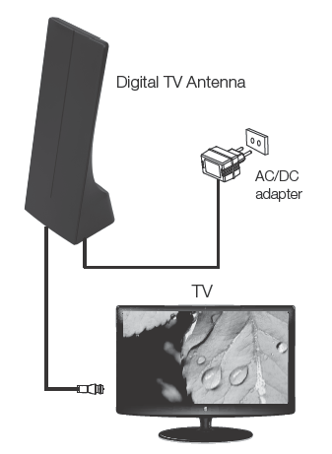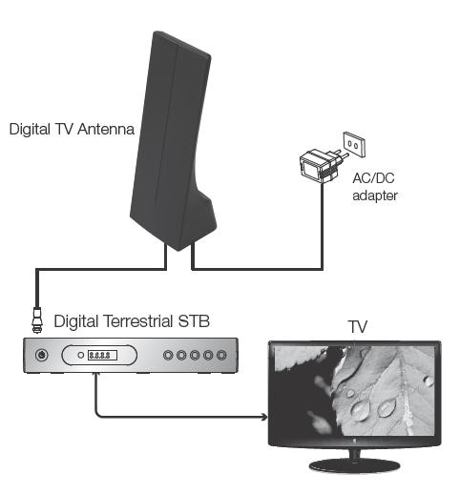
For TV with built-in tuner For TV without built-in tuner

(B) Powered by digital receiver
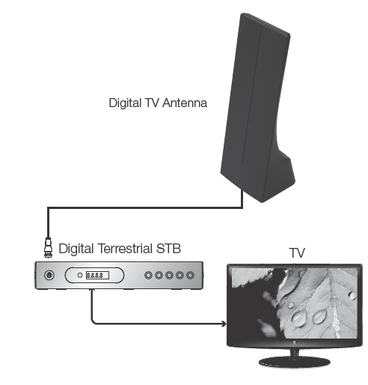

2. Turning the antenna on & Gain Adjustment
Turn on the antenna by rotating the MIN/MAX switch and adjust the gain control until you get the best reception.
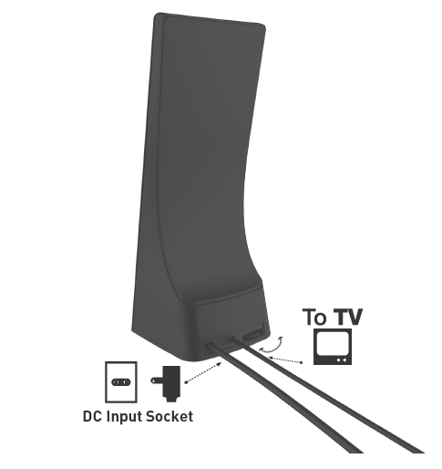

3. Adjustment on receiving direction
Adjust the antenna to different angles until you get the best reception.
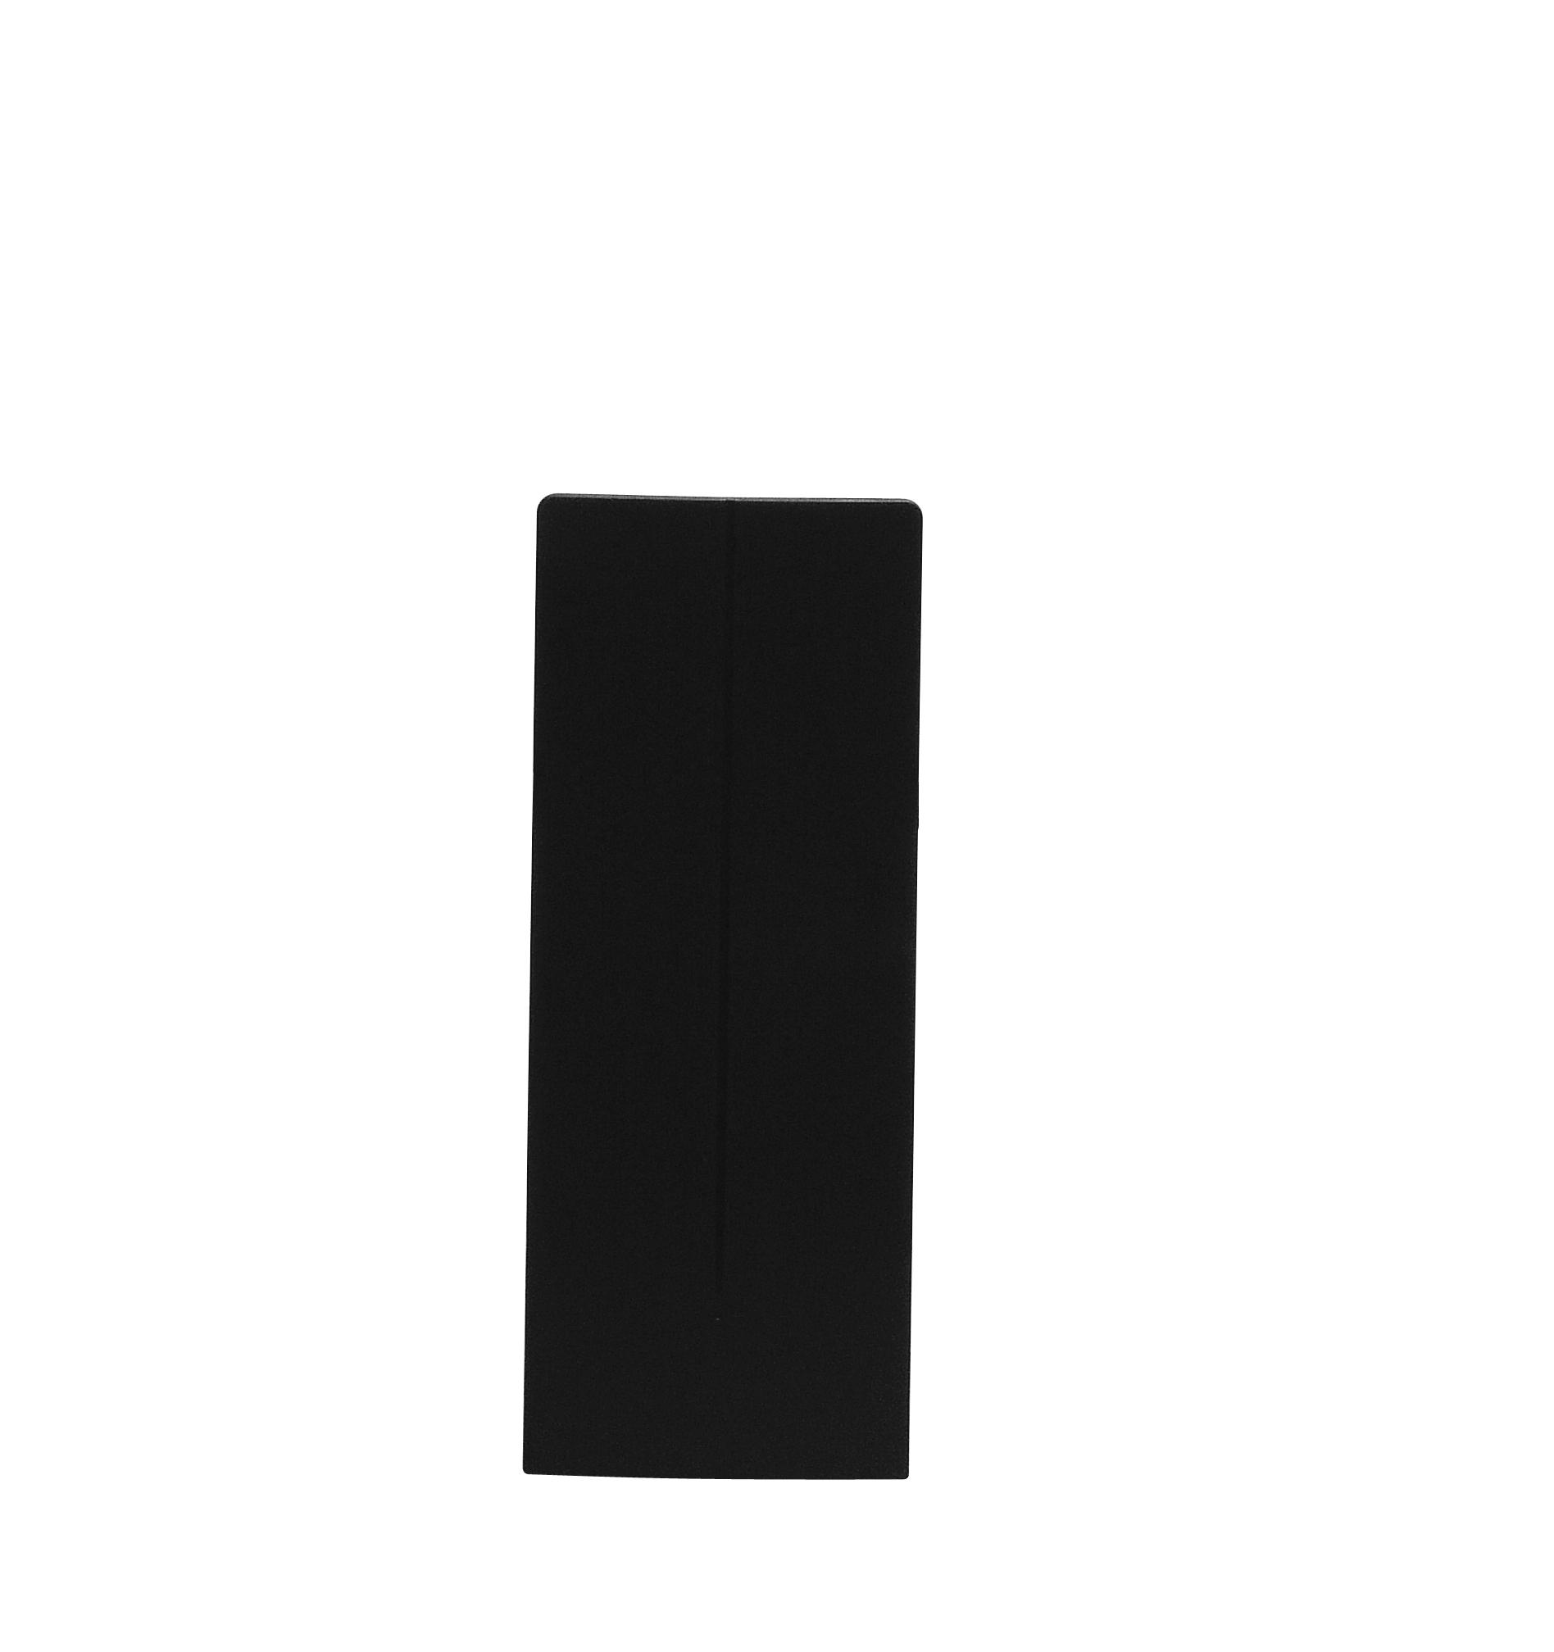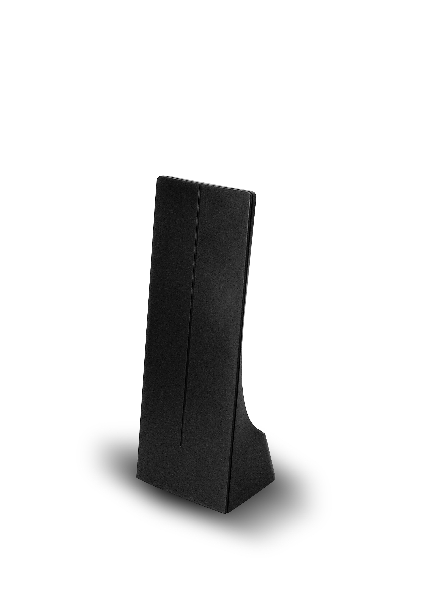

NOTICE
Stop using during thunderstorms and turn off the power.
Turn off the power when not in use.
If it can’t receive well, place the antenna in a different position.

