Installation Manual

Model - MG-ANT-8

Product Description
Ultra Flat Panel TV Antenna

Technical Specifications
*Frequency range: VHF: 174~230MHz / UHF: 470~862MHz
*Impedance: 75 Ω
*Connector: F connector

Installation Steps

Ⅰ. Antenna Assembly

- Attach the stand to the bottom of the antenna, be sure the stand is in the middle and antenna is fixed.
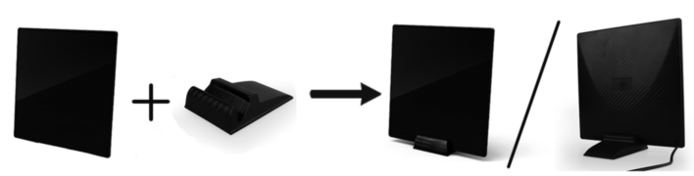

- Remove the protective film from the face of the antenna.

Ⅱ. Installation

1. Connect to TV
(A) For TVs without built-in tuner
Attach the coaxial cable from the antenna to the ANT jack of your digital receiver.

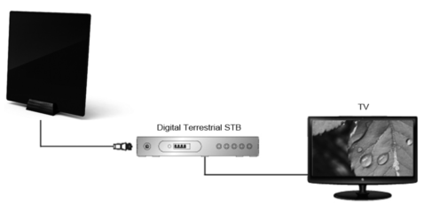

(B) For TVs with built-in tuner
Attach the coaxial cable from the antenna to the TV’S antenna input
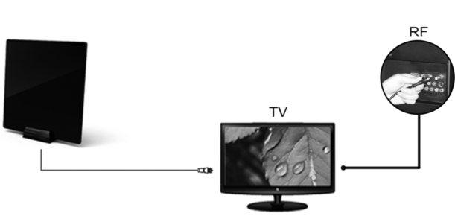
2. Set to antenna
Turn on your TV. In your TV’s setup menu, set the tuner mode to “Antenna” or “Air”
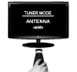

3. Scan for channels
In your TV’s setup menu, set the TV to “scan” or “auto-scan” for channels.


Notice
*To ensure you receive the maximum number of channels you may want to experiment re-positioning the antenna and re-scanning for channels.

