Installation Manual

Model – MG-ANT-6

Product Description
Indoor TV Antenna

Technical Specifications
*Frequency Range: VHF: 174-230MHz/UHF:470-862MHz
*Impedance: 75Ω
*Connector: F connector

Installation Steps

I. Antenna Assembly

1. Insert the square ring inside the corresponding socket, ensure full contact.
2. Place two bars in corresponding sockets, ensure tight fit
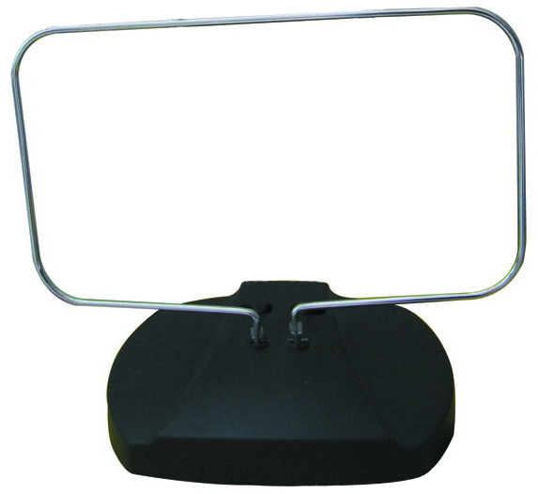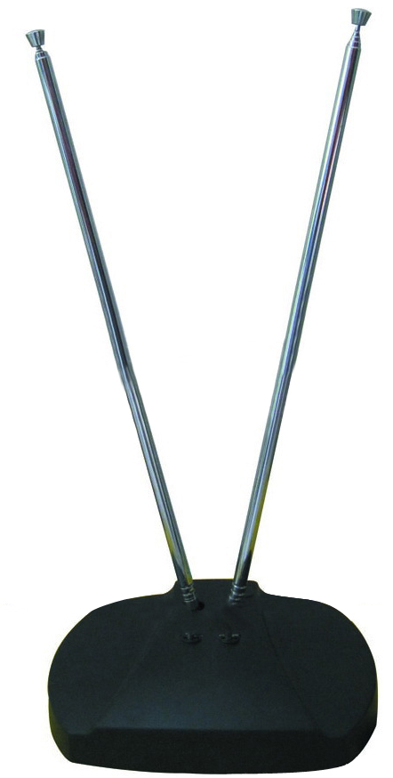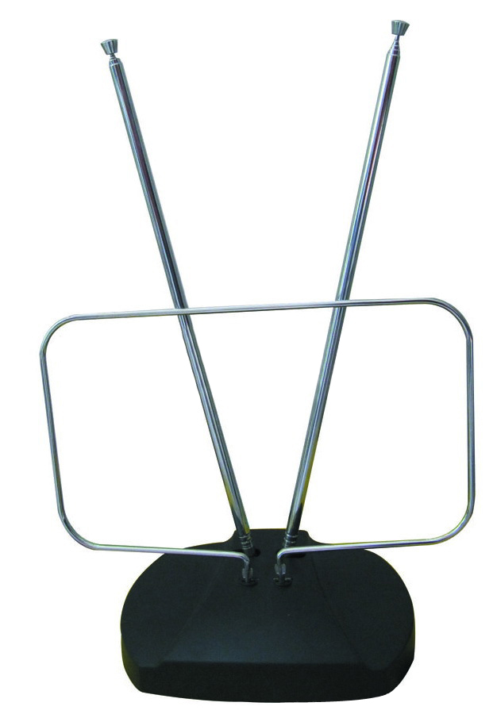
II. Installation

1. Connect to TV
(A) For TVs without built-in tuner
Attach the coaxial cable from the antenna to the ANT jack of your digital receiver
(B) For TVs with built-in tuner
Attach the coaxial cable from the antenna to the TV’s antenna input
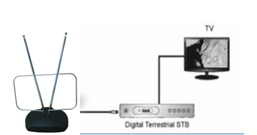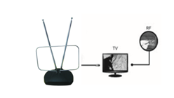

- Set to antenna
Turn on TV, in your TV’S setup menu, set the tuner model to “antenna” or “Air”. 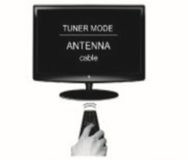
- Scan for channels
In your TV’s setup menu set the TV to “scan” or “auto scan for channels”.


Notice
To ensure you receive the maximum number of channels you may want to experiment re-positioning the antenna and re-scanning for channels.

